2008
Authored by: Trevor Fernandez
Prepared for: Mr Faulks
Applied Information Technology 2A 2B
Text and Formatting
[Type the document subtitle]

Contents Page

Describe and show examples of: 2

Show some examples of: 2

Insert here some Typeface families for Serif..3

Insert here some Typeface families for San Serif 3

Comment on the publication below suggest improvements or say why you like it: 5

Describe and show examples of:
- Leading is the amount of vertical space between lines of typing.
- Kerning is the process of adjusting the spacing between individual letters to fit into the font being used.
- Justification is the alignment of setting of text and images within a column.
- Typeface is usually comprises an alphabet of letters, numerals, and punctuation marks; it may also include ideograms and symbols
- Points
- Subscript is a number, figure and symbol that appear smaller than the normal line of text, it is found slightly higher or lower than the text.
- Serif is the non-structural details on the end of letters that make up letters and symbols.
- Sans Serif is the opposite of serifs as they don’t have little additions onto the letters or symbols.
- Tabs stops are often used to create easy-to-format documents.
- Line Spacing is the same as Leading.
- Simple Text is for the Mac OS (cough Mr Faulks). It allows editing of text and text formatting, it’s a like windows notepad.
- Bullets in the Text pane are different from bullet characters applied to text in a Microsoft Office system document. Each bullet in the Text pane corresponds to information that is used to arrange your SmartArt graphic.
- Case means upper or lower case.
- Page Break a page break is a marker in an electronic document, which tells the document interpreter that the content which follows is part of a new page.
- Text Wrap is where the text is wrapped around the image.

Show some examples of:
- Text Font Samples
Perpetua
Arial
Copperplate Gothic
- Show some examples of different fonts
Bodoni MT
Bodoni MT black
Bodoni MT Condensed
- Word art curved, vertical, horizontal/standard
Angled



- Show a sample of two types of drop caps

This article is to show the affect of drop caps, as you can see the capital letter from the first word is enlarged and dropped.

This article is to show an example of drop capping into the margin.

- Show samples of two (2) indent types

Indenting text is very handy.
Indenting text is very handy.

Insert here some Typeface families for Serif
- Bodoni MT bold
- Bodoni MT Black
- Bodoni MT Condensed

Insert here some Typeface families for San Serif
- Copper Black
- Copperplate Gothic Bold
- Copperplate Gothic Light

The following words are 3 different typefaces.

1 ROME CIRCUS STEEL

2 ROME CIRCUS STEEL

3 ROME CIRCUS STEEL

Which is the most appropriate (i.e. creates the desired mood) for:

Kindergarten | 2,3
TAFE Bulletin | 1,2
University Student newsletter | 1
Under 18’s Football Club | 1,2
Bowling Club | 1,2

Discuss and show typestyles (Bold, Strike through etc)
Super Script is where a number or letter is placed above the normal line of text: x³
Subscript is where a number or letter is placed under the normal line of text: x₂
Underline means the selected text is underlined: Underline
Italic feature makes all words tilt on a slight angle: Italic
Bold feature makes each font stand out by thickening the font: Bold
Strikethrough is where a line strikes through the selected text: Strikethrough
Bullet Points are shown bellow:
- Bullet Points 1
- Bullet Points 2
- Bullet Points 3

Comment on the publication below suggest improvements or say why you like it:
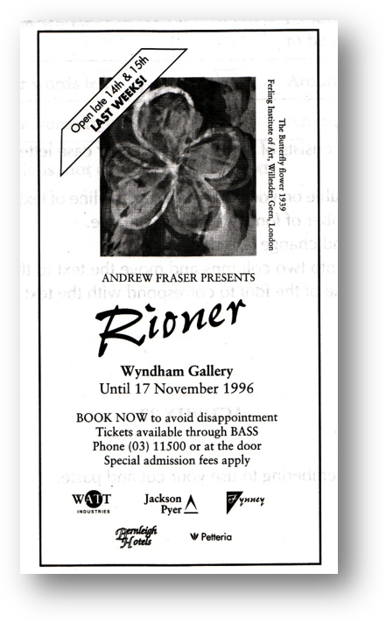
Answer:
I believe there is room for improvement in this advertisement for the Concert. It is very plain and many other advertisements look the same. There is nothing really eye grabbing about the way it’s presented so people passing by won’t bother to read it. Another factor I’m not fond off is that the text direction running down the side of the picture make the poster seem less professional as all the other text is centered. Also by bolding the Andrew Fraser part the viewers will know the presenter straight away.

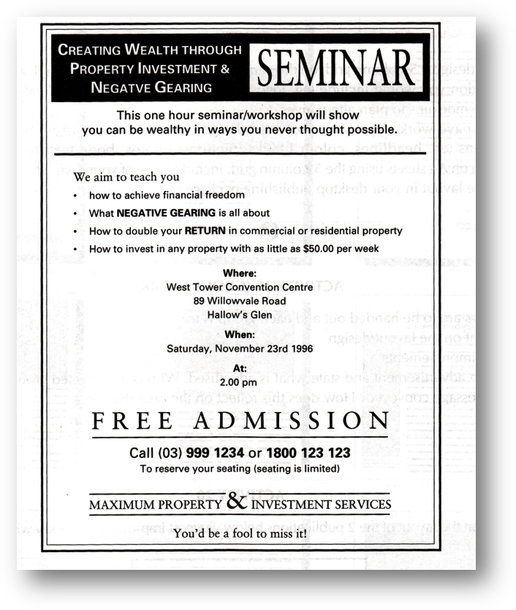

Answer:
I find this advertisement simple and straight to the point. All the important facts are bolded such as Where, When. The title is very eye catching because of the contrast used of a light and dark colour. The words Free Admission has character spacing to highlight the fact that this seminar is free and the underline message after the title, advises the reader to continue reading instead of walking away. The aims of the seminar are in bullets instead of long sentences, this makes it short and straight to the point like an advertisement should be.

Playing with text – in Fireworks
Fireworks have wonderful text control capabilities for typography. Spend a little time learning these few techniques, read up a little on typography methods, and you will be easily adding professionally designed text to your pages

Using Fireworks create a spectacular font with the create paths command in Fireworks Text.
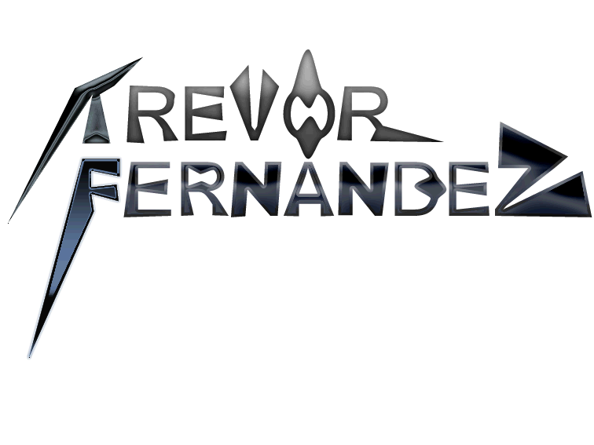

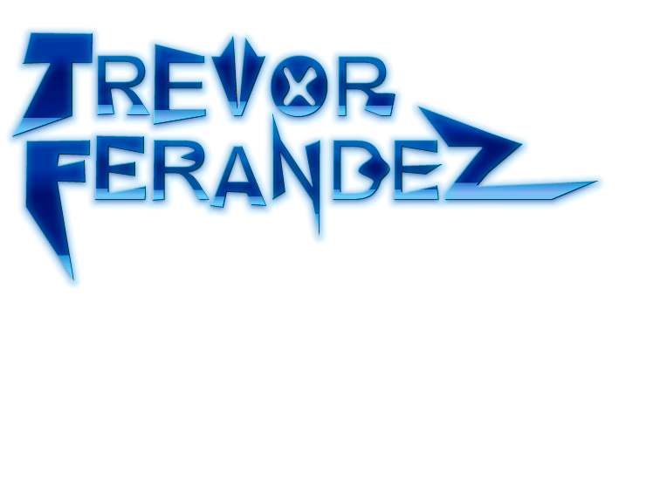

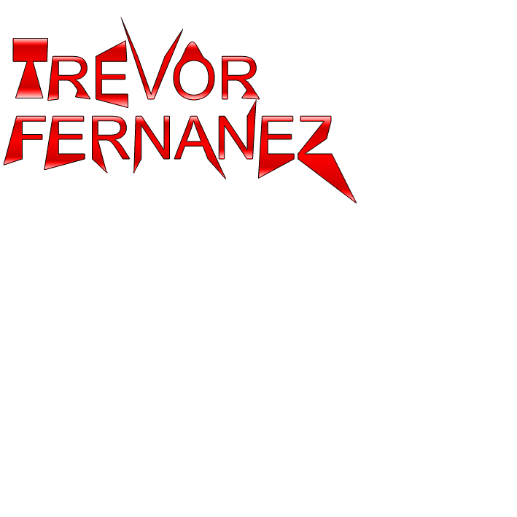

References:
www.wikipedia.org
www.microsoft.com

Memo Example
To: Mr Faulks
CC: Bobby
From: Trevor Fernandez
Date: 21/11/2003
Re: Mac Book Airs

How to Use This Memo Template
Select text you would like to replace, and type your memo. Use styles such as Heading 1-3 and Body Text in the Style control on the Formatting toolbar.
To delete the background elements—such as the circle, rectangles, or return address frames, click on the boundary border to highlight the “handles,” and press Delete. Some of the objects are part of a background watermark, so you have to choose Header and Footer from the View menu in order to select them. To replace the picture in this template with a different one, first click on the picture. Then, on the Insert menu, point to Picture, and click From File. Locate the folder that contains the picture you want to insert, then double-click the picture.
To save changes to this template for future use, choose Save As from the File menu. In the Save As Type box, choose Document Template. Next time you want to use it, choose New from the File menu, and then double-click your template.
Confidential

